WELCOME
Coaches’ Corner
We are happy to announce that Nikki Westlake will be our Head Coach this season!!

Big Welcome to MC Kistler, who will be an Asst Coach, along with Savannah Snow, who will also be an Asst. Coach.

Also on our coaching staff is Jenny Westlake and Sam Bingham, who will be our Junior Coaches.

The entire coaching staff is looking forward to a fun and exciting season.

You can read more about the coaches on the MOR at Silverton website:
https://www.moratsilverton.com/silverton-sharks-meet-the-coaches/

Welcome to the Silverton Sharks Swim Team! We look forward to sharing another great season with you. We are excited to see all the returning swimmers and we are thrilled to welcome many new Shark Swimmers and families.

Our goal for 2021 is to provide a positive summer swim team experience that is fun and rewarding for all swimmers. The Social Committee has a lot of fun events planned for the team! The kids can look forward to Flick and Floats, Social Events, Morning Outings, the Annual DJ party, and a few other spectacular events, as well!
Registrations for Summer Memberships and Swim Team are now OPEN
MORatSilverton.com

eSoft link here

In addition to our regular scheduled meets, our team will be participating in the Cary City Invitational on July 17 (if it is scheduled this year).

Go SHARKS!
2021 Swimmer Fees

- $119/first swimmer/family
- $99/second swimmer/family
- $89/third swimmer/family
- $79/any additional swimmer/family

Swim Team Practice
Starts Mon, May 24th for ALL swimmers!

It is REQUIRED that all swim team members be registered ONLINE and that parents register for their 4 volunteer positions ONLINE BEFORE your children can start practice. See website for practice times.
https://www.moratsilverton.com/silverton-sharks-swim-team/

Volunteer positions will be done through a SignUp Genius

SWIMMINGLY….How we run our swim meets.

Look at the Swimmingly website here. It gives a wealth of information. Training will be offered before time trials for new parents. This software was made for TSA swimming. Our hope is that a few of the volunteer positions we previously needed will be eliminated, and the ones that remain will be more fun!

What this means for you:
Parent access to your child(ren)’s swimming information.
There is also a $4 fee per swimmer which is included in the swim team fee.

We hope you will agree that this is a good investment for our team.

Silverton Shark Swim Team Committee

Volunteers

When you register online for the swim team, each family will sign up for at least 4 required volunteer positions to be performed during the 2021 swim season. Prior to registering for the team, we recommend that you read the volunteer job descriptions posted on the team’s website or in the Handbook posted on the website to familiarize yourself with all the duties of each volunteer job. Parents will be required to volunteer for at least 4 volunteer positions. There are exceptions for parents who ONLY have a 6 and under swimmer (at least 3 positions).
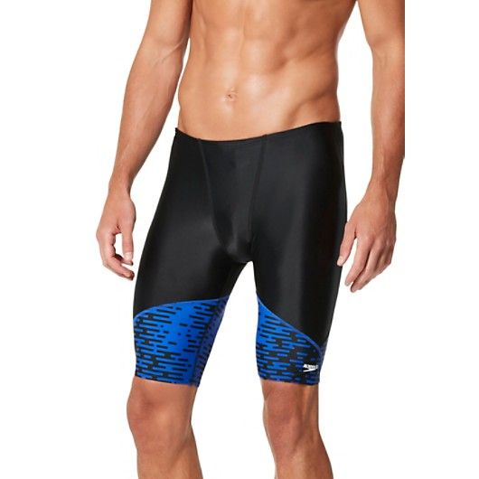
Swim Team Suits can be purchased at InSideOut Sports or click here.
Preston Walk Shopping Center
2002 Grisdale Lane
(919) -466-0101

Swimming Requirements to Join Swim Team

- 6&U’s must be able to swim 20 yards unassisted (without touching the bottom or lane rope) BEFORE joining the team and participating in practice.
- 7&8’s must be able to swim the full 25 yards unassisted (without touching the bottom or lane rope) BEFORE joining the team and beginning practice.
- If you are not sure whether your child is capable of swimming this distance UNASSISTED, we will provide opportunities for your child to be assessed prior to swim team starting.

Volunteer sign up will be on-line ONLY through a Sign Up Genius.
Stay Informed

Join our REMIND to get weekly meet info and social event updates.
Friend the Silverton Sharks Swim Team on FACEBOOK: http://www.facebook.com/home.php#!/groups/132464960107447/?fref=ts
Join our TWITTER account to get updates on practice/meet cancellations or rain delays:
www.twitter.com/SwimSilverton
Please be aware that no swimmer will be allowed to practice until parents sign up for their volunteer roles. The team counts on you to treat your volunteer assignments as a responsible commitment that you made when you registered your child for the Sharks.

Swim Team Committees
It takes a lot of people to make a swim team run smoothly. Please consider volunteering for one of the following committee positions below.
Open positions for the 2021 season:
- Stroke & Turn Judges (4 needed)- CRITICAL – can’t have a meet without them
- Big Shark/Little Program (1 needed)
- Communication – send out weekly newsletters to swim team via REMIND and FB
- Concession committee (3-4 people needed) - Run concessions at all 3 home meets
  - Will be your 4 volunteer positions
Please do your part in helping our swim team remain a healthy organization by volunteering. Please email Susan Fairlee, our Meet Coordinator, here if you would like to volunteer for a Committee Chair position or have a question about a position.

Big Shark/Little Shark Program

The goal of this program is to help form strong relationships between our team’s oldest and youngest (all 6 and under and new 7-8) swimmers. The Big Sharks help foster the overall spirit, sportsmanship, and commitment to our team. All 12 and over swimmers are welcome and encouraged to participate in this program. Please sign up at OPEN HOUSE on Saturday April 24 or Sunday April 25 or click the link below for the application and bring it to the Open House.
https://www.moratsilverton.com/wp-content/uploads/2018/01/big_shark_contract.pdf

